BLUECONX©ICOM/CELL PHONE PTT EARPIECE
Features:
- Custom dual firmware for Icom Radios and cellphone use
- Does not require purchase of external adaptors/ interfaces
- Dual PTT: One-Touch on/off and true PTT keying (select in the radio)
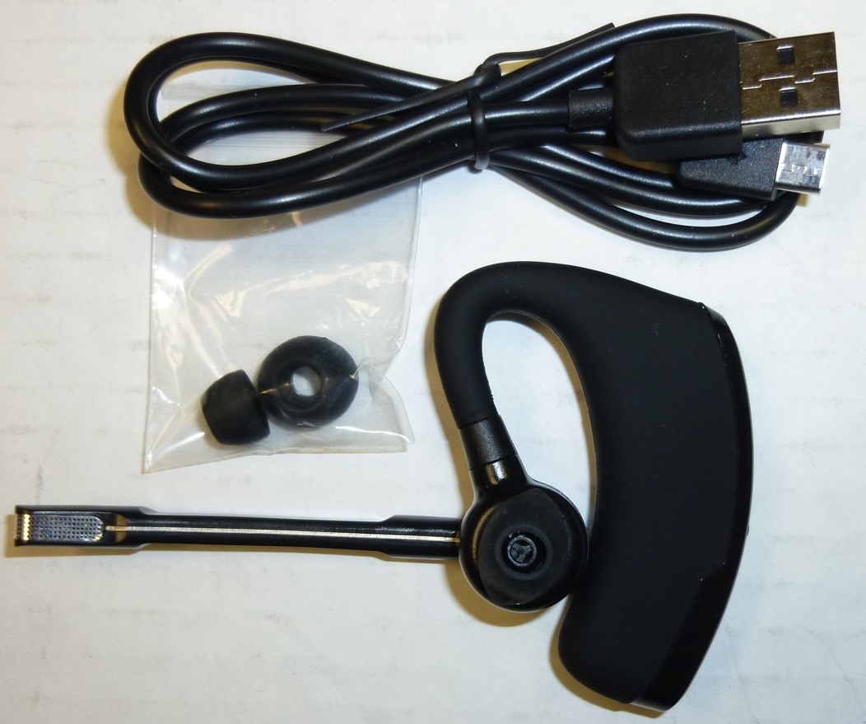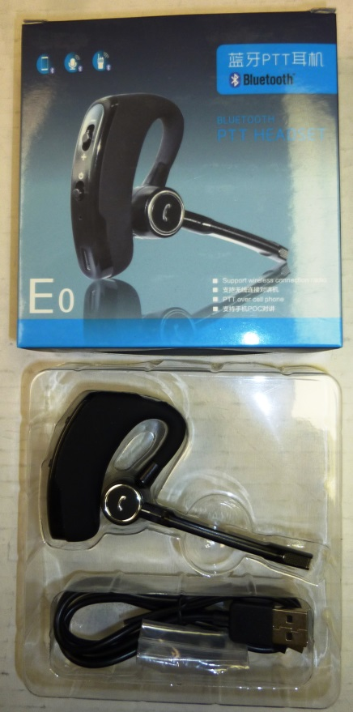
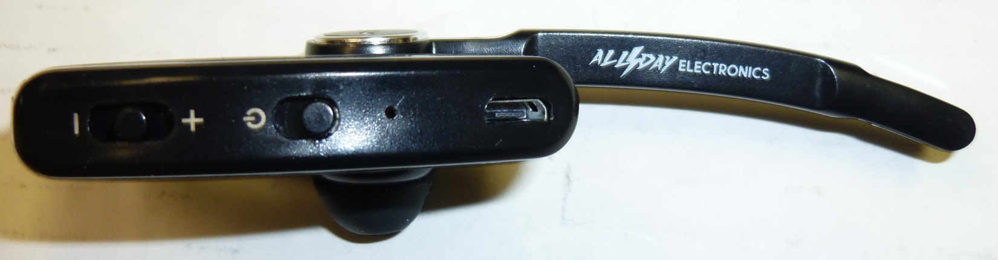
WORKS WITH F34OO/44OO/52/62, IP501, P25 RADIOS & PROBABLY MORE
BUY YOURS TODAY FROM ENTERPRISE ELECTRONICS 310-534-4456

